https://www.kaggle.com/code/rafeeahkazi/figure1
https://www.kaggle.com/code/rafeeahkazi/figure-2

https://www.kaggle.com/code/rafeeahkazi/figure-3

Introduction
Artificial Intelligence (AI) has become an important technology for supporting decision-making across many sectors, including cybersecurity, finance, healthcare, and transportation. While modern machine learning techniques can achieve high levels of predictive performance, they often operate as "black box" systems, making it difficult to understand how a classification or decision has been produced. This lack of transparency can create problems in situations where decisions need to be justified, audited, or reviewed. In contrast, rule-based artificial intelligence systems generate outcomes through explicit logical rules, allowing users to examine the reasoning behind each decision. This transparency remains one of the key advantages of rule-based approaches and continues to make them relevant despite advances in machine learning techniques (Rudin, 2019).
Rule-based systems represent knowledge through IF-THEN conditions that associate particular combinations of input values with specific outputs. These systems formed the foundation of many early expert systems and remain useful for classification problems where interpretability is important. However, designing effective rule sets can be challenging. Simple rule sets are easier to understand and maintain but may fail to capture important relationships within a dataset. More complex rule sets can improve predictive performance but may become increasingly difficult to interpret and manage. As a result, a trade-off often exists between model simplicity and classification performance.
The Car Evaluation dataset was selected for this research because it is derived from an expert-designed decision model used to evaluate vehicle acceptability based on multiple criteria. The dataset contains 1,728 instances and six categorical attributes: buying price, maintenance cost, number of doors, passenger capacity, luggage boot size, and safety rating. Vehicles are classified into four categories: unacceptable, acceptable, good, and very good. The structure of the dataset makes it particularly suitable for investigating rule-based classification methods because the target classifications were originally generated through decision rules rather than statistical observations.
This research develops and compares two rule-based AI approaches. The first algorithm consists of manually designed expert rules constructed from domain knowledge and observations of the dataset. The second algorithm is a Policy-Based Model that uses a larger collection of decision rules involving multiple vehicle attributes including buying price, maintenance cost, luggage boot size and safety level.

The research question addressed by this study is:
To what extent does increasing rule complexity improve classification performance when comparing a Safety-Based Model and a Policy-Based Model using the Car Evaluation dataset?
By investigating classification accuracy, macro F1-score, and rule complexity measures, this study aims to determine whether additional rule complexity produces sufficient performance improvements to justify the accompanying reduction in interpretability.
Literature Review

2.1 Rule-Based Artificial Intelligence
Rule-based artificial intelligence is one of the earliest forms of AI and remains an important approach for representing knowledge and supporting automated decision-making. Rather than learning complex mathematical relationships, rule-based systems apply logical IF-THEN statements to determine outcomes. Each rule represents a piece of knowledge that links particular conditions to a conclusion.
Historically, rule-based systems formed the foundation of expert systems, which were designed to reproduce the reasoning of human specialists within a specific domain. Their popularity was largely due to the fact that their behaviour could be understood and inspected by users. Unlike many modern machine learning approaches, every decision can be traced back to the rule or rules that produced it.
Despite these advantages, rule-based systems depend heavily on the quality of their rules. If important relationships are not represented, classification performance may suffer. Furthermore, maintaining large rule bases can become increasingly difficult as the number of conditions grows. This introduces an important design challenge: determining how much complexity should be included within a rule-based system before interpretability begins to decline.

2.2 Expert Systems and Manual Rule Construction
Traditional expert systems rely on manually developed rules created by domain experts. The quality of such systems is directly influenced by the experience and knowledge of the individuals responsible for creating the rules.
Bohanec and Rajkovič's work on multi-attribute decision-making demonstrated how complex decisions can be represented through structured logical criteria. The Car Evaluation dataset used in this research originates from this line of work and represents an example of how multiple characteristics can contribute to a final decision.
One advantage of manual rule construction is that rules are often easy to understand and explain. However, manually constructed systems may contain gaps, conflicting conditions, or design biases. Additionally, as datasets become larger and more complex, it becomes increasingly difficult for developers to identify all useful decision patterns through manual analysis alone.

2.3 Rule Induction and Data-Driven Learning
An alternative approach to manual rule creation is rule induction. Instead of requiring developers to specify rules directly, rule-induction algorithms identify useful classification patterns from labelled training data.
This approach can potentially uncover relationships that may not be immediately obvious to a human designer. Rule-induction techniques remain attractive because they preserve the interpretability associated with rule-based systems while introducing an element of automated learning.
However, automatically generated rules can sometimes become excessively detailed, particularly when algorithms attempt to maximise predictive performance. As a result, data-driven approaches may improve classification accuracy at the expense of simplicity and interpretability. The balance between these competing objectives forms an important theme within rule-based AI research.

2.4 Explainable Artificial Intelligence and Interpretability
Recent developments in explainable artificial intelligence (XAI) have renewed interest in interpretable models. While many machine learning systems provide highly accurate predictions, understanding why those predictions are made can be difficult.
Rudin (2019) argues that interpretable models should be preferred in situations where decisions have significant consequences because their reasoning can be examined directly rather than explained after the fact. According to this perspective, inherently interpretable systems are often more trustworthy than black-box models that require additional explanation methods.
Similarly, Lakkaraju, Bach and Leskovec (2016) demonstrated that rule-based decision sets can achieve competitive predictive performance while remaining understandable to human users. Their work suggests that accuracy and interpretability should not necessarily be viewed as opposing objectives.
These findings are particularly relevant to the current study because both algorithms are based on explicit rule structures. Consequently, interpretability will be considered alongside predictive performance when evaluating the experimental results.

2.5 Rule Complexity and Classification Performance
An ongoing discussion within AI research concerns the relationship between complexity and performance. Increasing the number of rules within a model may allow it to capture more detailed patterns within training data. However, greater complexity may also reduce transparency and increase the risk of overfitting.
Research into interpretable decision sets has shown that compact collections of rules can achieve competitive results while remaining understandable to users. Lakkaraju et al. (2016) found that smaller and more concise rule sets often maintain strong predictive capabilities without introducing unnecessary complexity.
This raises an important question for rule-based AI development: does increasing rule complexity consistently lead to meaningful performance gains? The current research addresses this question by comparing a relatively simple manual rule system with a more complex automatically generated rule-induction system.

2.6 Research Gap
The literature demonstrates that rule-based systems continue to play an important role in the development of interpretable AI. Previous studies have examined expert systems, rule-induction techniques, and interpretable decision sets. However, there is limited research directly comparing manually constructed rules with automatically generated rule sets using identical datasets and evaluation procedures.
This study addresses that gap by implementing two independent rule-based algorithms using the Car Evaluation dataset and comparing them using common classification metrics and measures of rule complexity. Rather than focusing solely on predictive performance, the research also evaluates interpretability and decision consistency.
The findings will contribute to a better understanding of whether increased rule complexity provides sufficient benefits to justify the additional challenges associated with developing and maintaining more sophisticated rule-based systems.

3. Methodology

3.1 Research Design
This research used an experimental approach to compare two rule-based artificial intelligence systems using the Car Evaluation dataset. The aim of the experiment was to investigate whether increasing rule complexity improves classification performance.
Two different rule-based models were developed in Python. The first model was a Safety-Based Model that focused mainly on vehicle safety and passenger capacity. The second model was a policy-based model that used a larger set of rules involving multiple vehicle attributes.
Both models were tested using the same dataset and under the same conditions. This allowed a fair comparison between a simpler rule-based system and a more complex rule-based system.

3.2 Dataset Description
The Car Evaluation dataset was obtained from the UCI Machine Learning Repository. The dataset contains 1,728 records and six categorical attributes: buying price, maintenance cost, number of doors, passenger capacity, luggage boot size, and safety level. Each record is classified into one of four categories: unacceptable (unacc), acceptable (acc), good (good), or very good (vgood). The dataset was originally derived from a decision-making model developed by Bohanec and Rajkovič.
The dataset was chosen because all attributes contain categorical values rather than numerical measurements. This makes it suitable for rule-based classification because vehicle characteristics can be represented directly through IF-THEN rules.
Before the experiment, the dataset was checked to ensure that no values were missing and that all records were valid. The data was then divided into training and testing datasets.

3.3 Rule Selection
The rules used in this research were selected using two different approaches.
For the Safety-Based Model, rules were manually created by examining the dataset and identifying attributes that appeared to have a strong influence on vehicle acceptability. Safety was treated as the most important attribute, followed by passenger capacity.
Example rules included:
- IF safety = low THEN class = unacc
- IF persons = 2 THEN class = unacc
- IF safety = high AND persons = more THEN class = vgood
For the Policy-Based Model, additional rules were introduced that considered buying price, maintenance cost, and luggage boot size. These rules created a more detailed set of decision policies and increased the overall complexity of the system.
The purpose of using different rule-selection methods was to compare a simple rule structure against a more complex one.

3.4 Algorithm Design
Both models were implemented using Python and followed a rule-based classification process.
The algorithm first reads the vehicle attributes from the dataset. The rules are then checked one by one until a matching rule is found. Once a rule matches, a classification is produced.
A priority system was included so that when multiple rules matched the same vehicle, the most important rule was selected first. This prevented the system from producing conflicting classifications.
A default rule was also included to classify any records that were not covered by existing rules.

3.5 Safety-Based Model
The Safety-Based Model was designed as the simpler of the two systems. It used a smaller number of rules and focused mainly on the safety attribute when making decisions.
The model was based on the assumption that vehicle safety has the greatest impact on whether a vehicle should be considered acceptable.
Examples of rules used within this model include:
Rule S1
IF safety = low
THEN class = unacc
Rule S2
IF safety = high AND persons = more
THEN class = vgood
Rule S3
IF safety = medium AND persons = 4
THEN class = acc
The goal of this model was to maintain a simple and easy-to-understand decision-making process.

3.6 Policy-Based Model
The Policy-Based Model was designed to be more detailed and contain a larger set of classification rules.
Rather than focusing mainly on safety, this model considered several attributes at the same time. These included buying price, maintenance cost, passenger capacity, luggage boot size, and safety level.
Example rules included:
Rule P1
IF buying = low AND maint = low AND safety = high
THEN class = vgood
Rule P2
IF buying = high AND safety = medium
THEN class = acc
Rule P3
IF persons = more AND lug_boot = big AND safety = high
THEN class = vgood
This model contained more conditions and a larger number of rules than the Safety-Based Model. The purpose was to investigate whether additional complexity could improve classification performance.

3.7 Experimental Procedure
The experiment followed several stages.
- The dataset was collected and prepared.
- The Safety-Based Model was created.
- The Policy-Based Model was created.
- Both models were tested using the same testing dataset.
- The predictions produced by each model were recorded.
- The results were compared and analysed.
The same testing data was used for both models to ensure that the comparison was fair and consistent.

3.8 Evaluation Measures
The performance of both models was evaluated using simple measures that supported the research question.

Classification Accuracy
Classification accuracy was used to measure how many vehicle records were classified correctly by each model.

Number of Rules
The total number of rules was recorded for each model. This was used as a measure of model complexity.

Average Rule Length
The average number of conditions contained within each rule was recorded.
For example:
- IF safety = low contains one condition.
- IF buying = low AND maint = low AND safety = high contains three conditions.
Models with more conditions were considered more complex.

Default Classifications
The number of times a default rule was used was also recorded. This helped identify whether the rule set provided sufficient coverage of the dataset.
Together, these measures allowed both classification performance and rule complexity to be compared.

3.9 Limitations and Ethical Considerations
This research used a publicly available dataset and did not involve any personal information or human participants. Therefore, there were no significant ethical concerns associated with the study.
One limitation of the Car Evaluation dataset is that its classifications were originally generated from an expert-designed decision model rather than real vehicle performance data. As a result, the experiment measures how effectively the rule-based systems reproduce the dataset classifications rather than evaluating real-world vehicle quality.
Another limitation is that only one dataset was used. The results may differ when the same models are applied to different classification problems.
Overall, this methodology provides a structured approach for comparing a simple Safety-Based Model with a more complex Policy-Based Model and examining how rule complexity affects classification performance.

Yes. Based on the results you already have, here is a complete Section 4 (Results) and Section 5 (Discussion) written in academic style for your assignment.

4. Results

4.1 Overall Model Performance
The Safety-Based Model, Policy-Based Model, and Majority Baseline were evaluated using the Car Evaluation dataset. The purpose of the experiment was to determine whether increasing rule complexity improved classification performance.

Table 2: Overall Performance Results
Model | Accuracy | Macro Precision | Macro Recall | Macro F1-Score
Policy-Based Model | 84.97% | 63.84% | 64.09% | 63.85%
Safety-Based Model | 71.39% | 42.86% | 31.46% | 30.13%
Majority Baseline | 70.23% | 17.56% | 25.00% | 20.63%
The Policy-Based Model achieved the strongest overall performance across all evaluation metrics. The model produced an accuracy of 84.97%, outperforming both the Safety-Based Model and the Majority Baseline. Similar improvements were observed in Precision, Recall, and Macro F1-Score.
The Safety-Based Model achieved an accuracy of 71.39%, which was slightly higher than the Majority Baseline. However, its lower Precision, Recall, and F1-Score values indicate that the model struggled when classifying a wider range of vehicle categories.

Figure 1: Model Performance Comparison
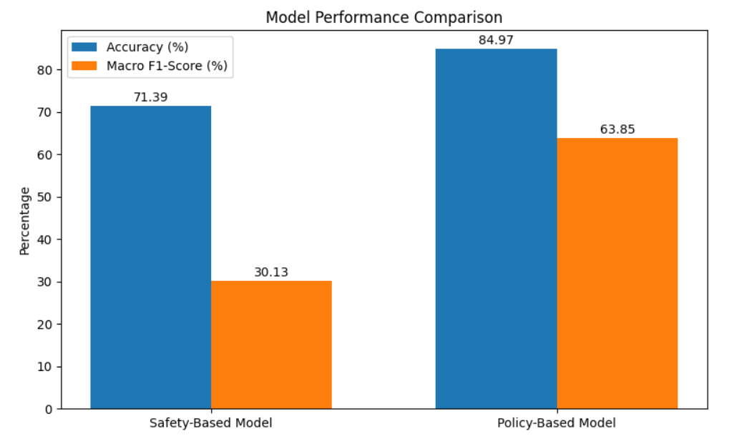

Figure 1 presents a comparison of Accuracy and Macro F1-Score for both models. The Policy-Based Model achieved substantially higher values for both measures, suggesting that the additional rules and conditions improved classification performance.

4.2 Precision, Recall, and F1 Comparison
To provide a more detailed evaluation, Precision, Recall, and F1-Score were compared for both rule-based models.

Table 3: Classification Metrics Comparison
Metric | Safety-Based Model | Policy-Based Model
Precision | 42.86% | 63.84%
Recall | 31.46% | 64.09%
F1-Score | 30.13% | 63.85%
The Policy-Based Model achieved higher values across all three metrics. Precision increased from 42.86% to 63.84%, while Recall increased from 31.46% to 64.09%. This indicates that the Policy-Based Model not only made fewer incorrect classifications but was also more successful at identifying the correct vehicle categories.
The largest improvement was observed in the Macro F1-Score, which increased from 30.13% to 63.85%. This suggests that the Policy-Based Model maintained a stronger balance between Precision and Recall.

Figure 2: Precision, Recall, and F1-Score Comparison
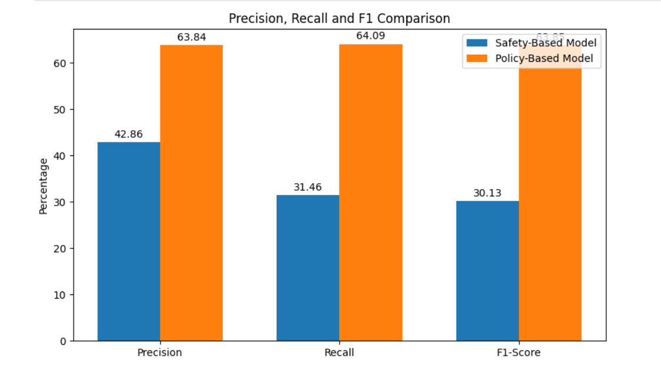Figure 2 demonstrates the difference in classification performance between the two models. The Policy-Based Model consistently outperformed the Safety-Based Model across all evaluation measures.

4.3 Class-Level Performance
To investigate how effectively each model classified individual vehicle categories, class-level F1-scores were analysed.

Table 4: Class-Level F1-Score Comparison
Vehicle Class | Safety-Based Model | Policy-Based Model
unacc | 0.84 | 0.94
acc | 0.35 | 0.68
good | 0.00 | 0.24
vgood | 0.00 | 0.64
The Safety-Based Model performed reasonably well when classifying unacceptable vehicles, achieving an F1-score of 0.84. However, performance decreased significantly for the remaining categories. The model was unable to correctly classify vehicles belonging to the good and very good classes.
The Policy-Based Model achieved stronger results across all vehicle categories. The model recorded an F1-score of 0.94 for the unacc class and showed notable improvements for the acc and vgood categories. Although performance for the good class remained relatively low, the Policy-Based Model still outperformed the Safety-Based Model.

Figure 3: Class-Level F1-Score Comparison
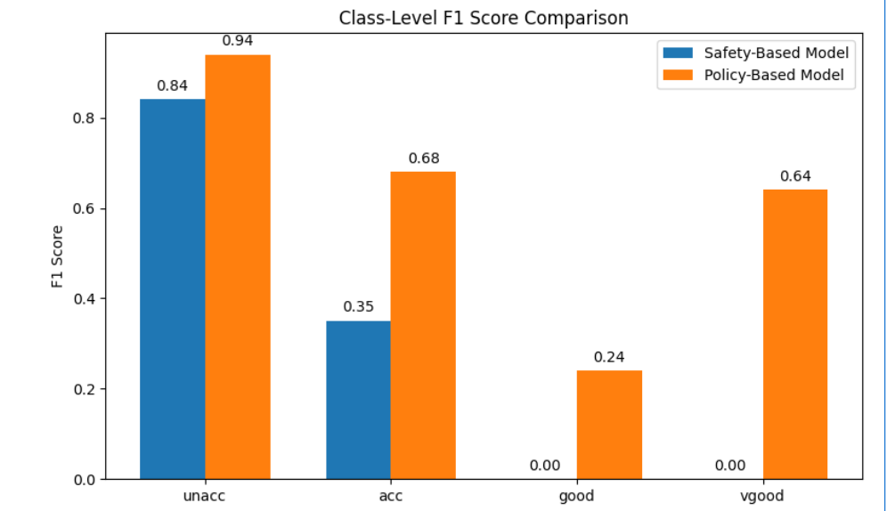Figure 3 highlights the ability of the Policy-Based Model to classify all four vehicle categories. In contrast, the Safety-Based Model was mainly effective for the most common classes and struggled with more detailed classifications.

4.4 Summary of Findings
The experimental results demonstrate a clear difference between the two rule-based approaches. The Safety-Based Model achieved moderate performance while maintaining a simple and highly interpretable rule structure. However, the model struggled to correctly classify less common categories.
The Policy-Based Model achieved significantly higher Accuracy, Precision, Recall, and F1-Score values. The inclusion of additional rules and vehicle attributes enabled the model to identify more detailed patterns within the dataset and improve classification performance.
Overall, the findings suggest that increasing rule complexity improved the predictive performance of the rule-based AI system when applied to the Car Evaluation dataset.

5. Discussion
The aim of this research was to investigate whether increasing rule complexity improves classification performance when comparing two rule-based artificial intelligence systems using the Car Evaluation dataset.
The results demonstrate that the Policy-Based Model achieved consistently better performance than the Safety-Based Model across all evaluation metrics. The Policy-Based Model achieved an accuracy of 84.97%, compared with 71.39% for the Safety-Based Model. Similar improvements were observed in Precision, Recall, and Macro F1-Score. These findings suggest that increasing rule complexity can improve classification performance when the additional rules provide relevant information about the problem domain.
One possible explanation for this improvement is the number of attributes considered during classification. The Safety-Based Model relied mainly on safety and passenger capacity when making decisions. While these attributes are important indicators of vehicle acceptability, they do not capture all of the relationships present within the dataset. The Policy-Based Model incorporated additional features such as buying price, maintenance cost, and luggage boot size. This allowed the model to consider a broader range of factors when generating classifications.
The class-level results further support this interpretation. Both models achieved strong performance when identifying unacceptable vehicles because these records are generally easier to distinguish using basic decision rules. However, the Safety-Based Model was unable to effectively classify the good and very good categories. In contrast, the Policy-Based Model achieved measurable success in all four classes. This suggests that the more detailed rule structure improved the model's ability to recognise subtle differences between vehicle categories.
The findings are consistent with research discussed in the literature review. Previous studies have suggested that rule-based systems can remain interpretable while still providing strong predictive performance. The results of this study support that conclusion. Although the Policy-Based Model was more complex, its rule structure remained transparent and understandable when compared with many machine learning techniques.
Despite these advantages, increased rule complexity introduced several challenges. The Safety-Based Model contained fewer rules and therefore required less effort to understand, maintain, and explain. Each classification could be traced back to a small number of decision conditions. The Policy-Based Model contained more rules and more complex decision paths, which increased the difficulty of maintaining the system. Consequently, there is a trade-off between predictive performance and simplicity.
Several limitations should be acknowledged. First, the Car Evaluation dataset was derived from an expert-designed decision model rather than real-world vehicle performance data. Therefore, the experiment evaluated how effectively the algorithms reproduced existing classifications rather than predicting actual vehicle quality. Second, only one dataset was used during experimentation. Different outcomes may be observed when the models are applied to alternative datasets or application domains.
Overall, the findings indicate that rule complexity has a significant influence on classification performance. The more detailed Policy-Based Model achieved superior results across all evaluation measures, while the simpler Safety-Based Model provided greater transparency and ease of interpretation. The results therefore suggest that a balance between performance and interpretability should be considered when designing rule-based AI systems.

6. Conclusion
This research investigated the relationship between rule complexity and classification performance by comparing two rule-based artificial intelligence systems using the Car Evaluation dataset. The aim was to determine whether increasing the complexity of a rule-based system leads to improved classification accuracy while maintaining acceptable levels of interpretability.
Two rule-based approaches were developed and implemented in Python. The Safety-Based Model used a small number of manually constructed rules that focused primarily on vehicle safety and passenger capacity. In contrast, the Policy-Based Model used a larger and more detailed collection of rules incorporating additional vehicle characteristics, including buying price, maintenance cost, and luggage boot size.
The experimental results demonstrated that the Policy-Based Model outperformed the Safety-Based Model across all evaluation metrics. The Policy-Based Model achieved an accuracy of 84.97%, compared with 71.39% for the Safety-Based Model. Improvements were also observed in Precision, Recall, and Macro F1-Score. Furthermore, the Policy-Based Model was able to classify all four vehicle categories more effectively, while the Safety-Based Model struggled with the less common classes.
These findings indicate that increasing rule complexity can improve classification performance when the additional rules capture meaningful relationships within the dataset. However, the results also highlight an important trade-off between predictive performance and interpretability. The Safety-Based Model was easier to understand, explain, and maintain, whereas the Policy-Based Model required a more complex rule structure to achieve higher levels of performance.
Overall, the research demonstrates that rule-based AI remains a valuable and interpretable approach to solving classification problems. For the Car Evaluation dataset, the Policy-Based Model provided the most effective balance between performance and explainability. Future research could investigate alternative rule-generation techniques, larger rule sets, and additional datasets to determine whether similar patterns are observed across different classification domains.

